The power of multiliteracy in The Gambia and Ghana

Ari Sherris, Associate Professor of Bilingual Education, Texas A&M University-Kingsville
Joy Kreeft Peyton, President, Coalition of Community-Based Heritage Language Schools

Citation: Sherris, A., & Peyton, J.K. (2023). The power of multiliteracy in The Gambia and Ghana. In A.C. Hager-M’Boua & F. Jaumont (Eds.), A bilingual revolution for Africa. New York, NY: TBR Books. A Bilingual Revolution for Africa – TBR Books (tbr-books.org)

Reading and writing remain a global challenge for people worldwide. In The Gambia and Ghana, 50% of young women who are 15-24 years of age cannot read and write (http://data.uis.unesco.org/). Many countries do not have effective systems in place to develop individuals’ reading and writing abilities in either the national language or their home/community language. In this chapter, we describe how a large nationwide project in The Gambia and a small tribal project in Ghana seek to develop multiliteracy in the population, beginning with children.

Keywords: marginalizing forces, multilingualism, multiliteracy, reading, writing

Reading and writing remain a challenge worldwide. Globally, at least 773 million youth and adults still cannot read and write, and 250 million children are failing to acquire basic literacy skills (UNESCO, 2021). As the World Bank (2021) points out, “nearly 37% of students in low- and middle-income countries are taught in a language they do not understand.”
In this chapter, we describe two projects: The Gambia Reads Programme and the Safaliba Project in Ghana. The Gambia Reads Programme was developed by the Ministry of Basic and Secondary Education in collaboration with the World Bank and Global Partnership for Education. The Safaliba Project is a small unfunded grassroots project. The aim of both projects is to develop early childhood literacy. In both cases, we argue that when multilingualism is linked to multiliteracy, four goals are accomplished: (1) an increase in the number of languages an individual can read and write; (2) an increase in the number of individuals who can read and write; (3) a reduction or mediation of marginalizing social forces in society and a rise in the linguistic capital of marginalized languages and groups (Bourdieu, 1977, 1983); (4) affirmation of, and respect and welcome for, potential family, clan, and community involvement in institutions and schooling.

Language and Literacy Development in The Gambia
The Gambia Reads Programme was first developed in 2008-2013, when, in reading assessments conducted in primary schools during 2007, 2009, and 2011, it was found that children were not reading and writing well. They scored very low on the Early Grade Reading Assessment (EGRA), which was developed to measure the levels of foundational literacy skills that children have to engage in reading and writing. (See Dubeck & Gove, 2015; Gove & Wettterberg, 2011, for discussion of uses of EGRA; see Report on Early Grade Reading Ability Assessment, 2011, for a description of the reading assessment process followed in The Gambia.) After these assessments were administered, the Ministry of Basic and Secondary Education developed the Gambia Reads Programme in 2015 to help children learn to read and write in the language they speak at home by using it also at school.
This focus grew out of recognition that multilingualism is a source of strength, the ability to read and write is essential to success in the country, and when children begin to read in their mother tongue, they make important language connections, starting with the oral language that they know (Goal 2: to increase the number of individuals who can read and write). They are then able to transition to English (the official language) (Goal 1: to increase the number of languages an individual can read and write). This focus brings into the education system, and into discussions about learning and advancement, the languages that communities speak, which up to then had been ignored in education in The Gambia (Goal 3; to raise the linguistic capital of marginalized language and groups). Finally, it recognizes and engages professionals (teachers, program administrators, teacher professional developers, curriculum developers, computer-competent educators), who have the opportunity to use their language to improve education in their country. Hymes (1980) described this as “a mutual relation of interaction and adaptation" between researchers/consultants and the people they work with, "a relation that will change both" (p. 89; Goal 4; to affirm, respect, and welcome community involvement in schooling).
By 2016, when the project described here officially began (it had started in 2011 as a pilot), instructional materials had been developed for Grades 1-3 to respond to the EGRA assessments. They supported literacy development in five Gambian languages and English. These materials, which included textbooks for children (referred to as pupils in West Africa) and teacher guides, were reviewed and revised by Gambian educators in the project described here, and materials were developed in two more Gambian languages. Curricula were prepared for Gambian language and English language development—speaking, listening, reading, and writing. New teacher guides (which describe ways to teach English and promote literacy in the Gambian languages) were written, as well as leveled readers in seven Gambian languages and English, for students in Grades 1-3, to improve their reading abilities. Teacher trainers were trained so that they could teach teachers to use these materials in their classes. The goal was that students would engage in oral and written language (reading and writing) development in their mother tongue for two hours per day in Grades 1, 2, and 3. At the same time, they would learn oral and written English for making a transition to English instruction in Grade 3. The component of the project described here is the writing, publishing, and use of the leveled readers.
The Gambia and Languages Chosen for Materials Development
The Gambia (Republic of The Gambia), shown in Figure 1, is located in West Africa, occupying 4,127 square miles, with a population of 2,486,937 (Population Pyramid, 2021). It is the smallest country on the African continent and is surrounded by Senegal, except for its opening from The Gambia River to the Pacific Ocean. In 2018, the population was 2,051,000, 11 languages were spoken, and the official language was English. The literacy rate was 56% (Simons & Fennig, 2018; citing the World Factbook, 2015).

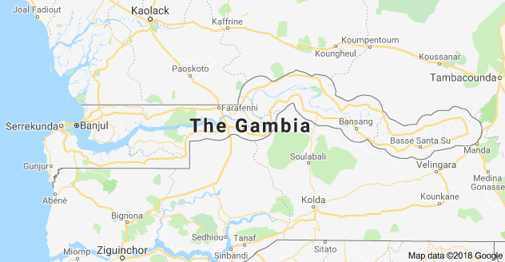
Figure 1. Republic of The Gambia

Figure 2 shows the number of speakers of each language, according to Simons and Fennig (2018), with the year the data were collected. The languages selected for materials development in The Gambia Reads Programme are marked with *.

* English (official language) – 60,000 (2,000 L1 speakers, 58,000 L2 speakers) (2016)
* Jola-Fonyi – 117,000 (2018)
Karon – 10,800 (2016)
* Mandinka – 879,000 (2014)
* Mandjak (Manjaku) – 37,700 (2018)
Maninkakan – 4,260 (2016)
N’ko – No known L1 speakers in The Gambia
* Pulaar - 377,000 (2018)
* Serahule – 130,000 (2018)
* Serer-Sine – 52,300 (2018)
* Wolof – 314,000 (2018)
Figure 2. Languages spoken in The Gambia and number of speakers

The reasons that the eight languages marked with * were selected for materials development can be associated with the classification of the languages in the Ethnologue (Simons & Fennig, 2018). English is the official language. Mandinka and Wolof are Languages of Wider Communication (used in work and mass media without official status to transcend language differences across a region). Pulaar and Serahule are Developing Languages (in vigorous use, with literature in a standardized form being used by some, though this is not yet widespread or sustainable). Jola-Fonyi, Mandjak, and Serer are Vigorous Languages (used for face-to-face communication by all generations, and the situation is sustainable). At the same time, the following languages were not selected for materials development. Karon is a Vigorous Language, but it is not used in schools; Maninkakan is a Threatened Language (used for face-to-face communication within all generations, but losing users); and N’ko is spoken only as a second language.
Book Development
Following revisions of the textbooks for students in Grades 1, 2, and 3, the teachers, school administrators, teacher educators, and professional writers who had worked on those materials—all are native speakers of the focal languages--were brought together to develop leveled readers, which would provide opportunities for pupils to practice the literacy skills they were acquiring in instruction using the textbooks. Work began with a set of themes (Grade 1, my family; Grade 2, my community; Grade 3, our country) and a set of topics for each theme. The writers developed books in the eight languages, using Bloom software (Bloom Library: Read). In each grade, books were written at three levels, based on the curriculum, to be 1) easy, 2) moderate, and 3) hard for that grade level. This was determined from the new curriculum, which guided selection of letters used (in Grade 1), words used, length of sentences, and length of stories for each level of difficulty in each grade. The books included comprehension questions to promote thinking about the content and discussion of the content among peers and small groups. The goal was that the books would be not only readable but also highly engaging – children would be engaged with the topics; want to read the books; develop the ability to read and write in their mother tongue and in English; and learn about the richness and beauty of their family, their community, and their country. All of the books produced were reviewed and edited by the language teams and project leaders, using a review rubric that was developed together, before they were finalized and printed. When they were finished, there were nine books in Grade 1 (three for each level), twelve books in Grade 2 (four for each level), and nine books in Grade 3 (three books for each level). Here are some examples of the book titles, in line with the theme for each grade, translated to English:
Grade 1 – My Family – A Party at Our House
Grade 2 – My Community - My Village Shops, We Celebrate Corate, We Go to the Ocean, My Friends Go to School
Grade 3 – Our Country – Taking Care of Our Rivers
Figure 3 shows one group of writers working together.
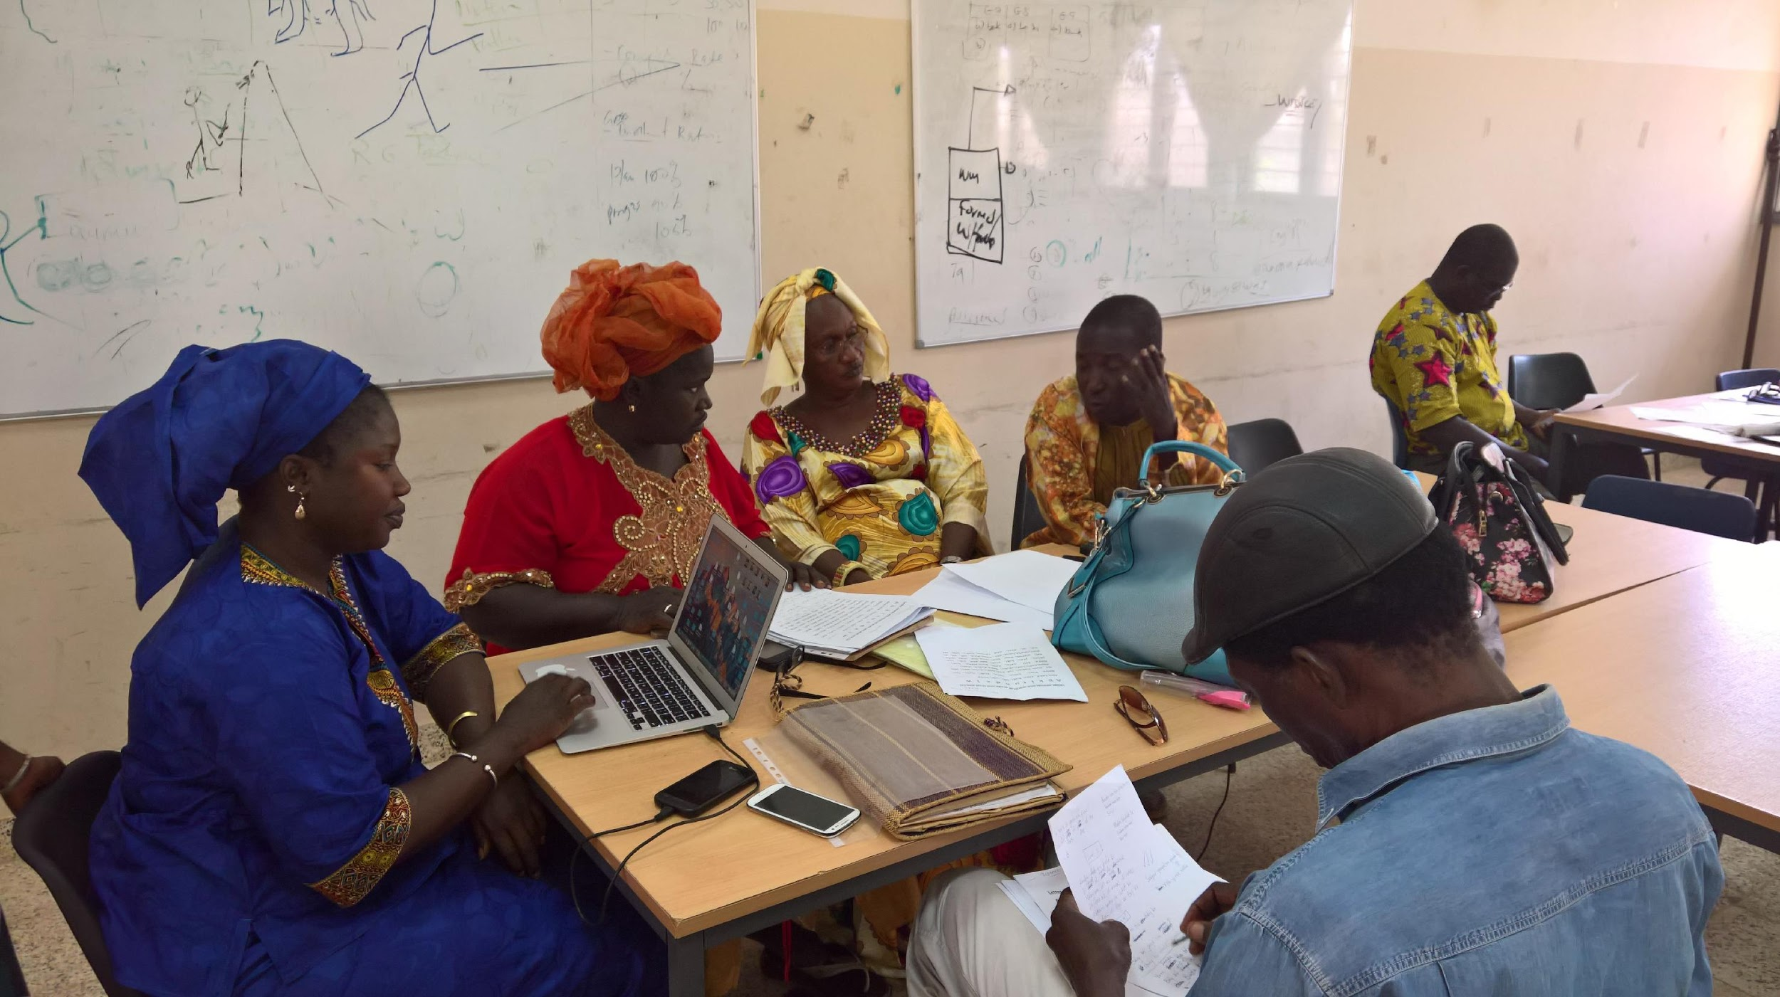
Figure 3. A group of writers developing leveled readers in Bloom

Successes
The leveled readers development resulted in a set of books that could be distributed to schools, which students could read and discuss in class, on their own, or at home with parents and other family members. The language teams, composed of individuals who were considered leaders in home language materials development (Goal 4), appreciated the importance of developing this new kind of reading material and making them available. Some of them wanted to come together again, for a longer and more intense time, and write more complex stories for students in higher grades.
Did the project result in an increase in the number of languages that the students could read (Goal 1), improved reading skills of the students (Goal 2), or increased linguistic and social capital of the students in civil society, government, and business (Goal 3)? This remains to be seen. Increasingly, Gambian educators and other leaders are interested in collecting data to answer these questions.
The project leads had ideas for other activities that they could be engaged in, which included:
- Write stories in the eight languages for teachers to read to Grades 1-3 pupils, possibly including big books. The stories would reflect the school curriculum and be written by accomplished writers and experts on culture, history, and geography of The Gambia, who are native speakers of one of the languages, to bring richness to the stories.
- Write stories for grades after Grade 3, possibly into secondary school, which would become richer and more complex as they progress through the grades. What is in place now is an “early-exit bilingual education system” (Trudell, 2016).
- Continue to develop resources and professional development opportunities for teachers.
- Continue to develop the literacy learning skills of the master trainers who manage and provide this professional development.
Challenges
The project faced a number of challenges (see also discussion of challenges, and proposed solutions, in Ancarno, Bouy, & Jeng, forthcoming).
- As shown above, one language classified as “Vigorous” was not included. We don’t know why. Decisions about languages of education were made before this component of the project began. What factors weighed into the decision? To what extent does it make a difference for speakers of that language?
- For some of the languages, there were disagreements among the writers about the orthography to be used.
- It was a challenge writing books for Grade 1, when students had not yet learned all of the letters of the language, and words that could be used in the books were limited in the beginning. Sound/symbol frequency in the language had not been taken into consideration when the textbooks were written.
- Not all of the team members had story writing and book production skills. They were educators, not always professional writers.
- Developing stories that were well-formed and interesting, and writing inviting, informative story titles was hard work, involving a lot of review and revision.
- Two hours per day learning in the mother tongue is not a lot of time.
- Not all of the teachers who will be involved in teaching children in their mother tongue and using these materials read and write the language well. They need to develop that proficiency, and they need support and mentoring. Many of the teachers had not taught in their mother tongue before. They need professional development in reading their Gambian language, in teaching it overall, and in using the materials.
- It is one thing to develop the materials and another challenge to get them into schools – printing, delivery, having a place to store them in the school. For a couple of years after the materials were developed, they were not in schools at all (there were no funds for printing and delivery), although one language group was able to pilot them. There was a hope to have them in schools by September of the following year.
There needs to be in place a plan and infrastructure for continuing to develop materials (especially leveled readers), use them in instruction, and review and evaluate their use. This goal can be difficult to accomplish because of financial and administrative challenges, even if key stakeholders support it. The World Bank (2021) argues that a policy package is needed to ensure that all children are taught in a language they understand, that instruction is effective, that training for teachers is available, and that there are engaging books and other resources in the language.
Questions to Ask in These Projects
There are a number of questions to be asked when engaging in a project of this type for it to be successful:
- For what grades will the books be developed?
- In what languages will the books be developed, and how are those languages selected?
- What will guide selection of themes, topics, and text features in the books?
- Who will be involved in writing the stories, and how much training and resources do they need?
- In what form will the books be made available? Low-cost, black and white, locally printed? Four-color durable paper?
- When the books are completed and available, how will they get into schools? Where will the funding come from for this delivery?
- How are the books linked to the curriculum and learning outcomes?
- How will teachers be encouraged to use the books and guided in their use?
- Can the time learning in the mother tongue be extended beyond two hours per day?
- What other preparation and support do teachers need to teach reading and writing in the community’s language, in their classes?
- Will teams continue to develop books over time, for the current grade levels or for more advanced grades? What systems and procedures need to be put in place for this to be accomplished?
The Grassroots Safaliba Project in Ghana
Language Policy Context
Ghana has a reported 83 languages; 73 of these languages are Indigenous. However, the Ghanaian government only produces and distributes materials to teach reading and writing in nine of Ghana’s Indigenous languages and in English, Ghana’s only official language (Lewis et al., 2016; Sherris, 2017, 2019, 2020 a, b). These languages are three dialects of Akan (Asante Twi, Akuapem Twi, and Fante, sometimes called separate languages) and the languages of Dagaare, Dagbani, Dangme, Ewe, Ga, Gonja, Kasem, and Nzema. This unfortunate policy, albeit typical of many multilingual nation states, leaves 64 Indigenous Ghanaian languages without government-issued materials to teach reading and writing and with mandates to use a different Indigenous language in instruction than the language that children speak at home in many schools.
The official language education policy is problematic for an additional reason. For the nine Indigenous Ghanaian languages that do have materials to teach reading and writing, the state-mandated curriculum limits their use to a two-year kindergarten program for children ages four to six and the subsequent first three years of primary school. After that, schooling and higher education are English-only endeavors, the iron-grip legacy of colonialism.
Moreover, when youth are not schooled in reading and writing in their language through adolescence, their knowledge, experience, and skill in their language abate and their confidence, at best, often falters over time. These social-psychological phenomena have deleterious effects on ethnolinguistic identity, social cohesion, and language vitality. This brief discussion sets the policy context for the focal language of this project, Safaliba, which we turn to next.
Spatial Distributions of Languages
One of the 64 languages left out of the official language education policy is Safaliba, which is spoken by an estimated 7,000-9,000 Safaliba who primarily live on their traditional tribal lands in the Savannah Region of Ghana. Eleven additional languages are situated in a 50-kilometer radius of the Safaliba lands. These include Birifor, Choruba, Dagaare, Deg, Gonja, Jula, Kamara, Lobiri, Siti, Vagla, and Waali (Figure 4). The Ghanaian government has developed and distributed materials to teach reading and writing in Dagaare and Gonja, as noted earlier, and the government provides the Safaliba, as it does other tribes in the Savannah Region, with Gonja materials. However, these materials are problematic for Safaliba speakers.
Gonja and Safaliba are morphosyntactically dissimilar, leading to difficulties for young children to learn to read and write. Perhaps this negative stimulus and the positive stimulus of the Safaliba people’s pride, esteem, and love for their language and culture have kindled the grassroots Safaliba literacy activism (Sherris, 2020) that is the focus of this project, which asks: What have the Safaliba accomplished to disrupt the reproduction of the Ghanaian postcolonial language education policy status quo?
The Safaliba language dominates the first seven towns listed in Figure 4 and is a contributing, albeit non-dominant, language in the last seven towns. Figure 4 has a small map of the nation-state of Ghana in the upper left corner. On the small map, Tamale, the most populated city in northern Ghana, and the Safaliba tribal lands are marked. The large map in the center of Figure 4 indicates the spatial or geographic distribution of the towns listed on the left-hand side. The grey area marks the Safaliba tribal lands. The tribal administration of the Safaliba lands is under the Gonja tribe. The Gonja, so local history tells it, arrived in the 1500s, invading the earlier inhabitants—the Safaliba, Choruba, Deg, Siti and Vagla. Sherris (2019) explores these issues more extensively.

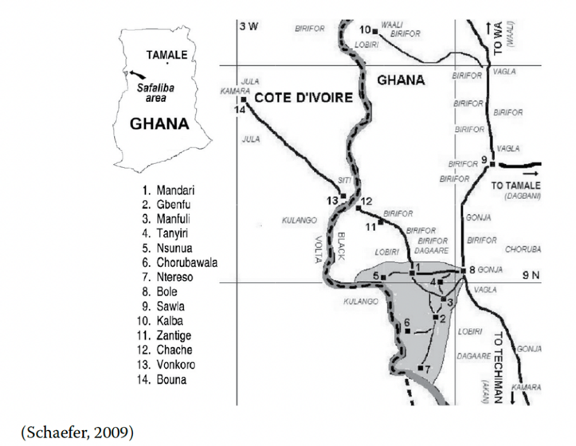
Figure 4. Nation State of Ghana

Research Approach
The documentation of the Safaliba is ethnographic. It is based on field notes, photographs, interviews, and video and audio recordings. Ethnography is both a reporting style and an approach that stresses learning from people rather than experimenting with them in some way.
Grassroots Safaliba Language and Literacy Activism: Disrupting the Reproduction of the Status Quo
Early grassroots Safaliba literacy activism initially stems from a letter that Safaliba storyteller, poet, and teacher Edmund Kuŋi Yakubu wrote in 1996 to the Ghana Institute of Linguistics, Literacy, and Bible Translation (GILLBT). In that letter, Yakubu shared his own Safaliba orthography and requested that GILLBT assign a linguist to conduct fieldwork in Safaliba communities to determine the viability of the Yakubu orthography (a copy of this letter is in Sherris, 2017). Two years later, in 1998, GILLBT sent Paul and Jennifer Schaefer to live among the Safaliba. Paul Schaefer made minor changes in Yakubu’s Safaliba orthography based on his fieldwork, and Yakubu’s orthograph was in play. The Schaefers have become long-term allies of Safaliba literacy activism and continue to collaborate in solidarity with both adult- and child-focused reading and writing programs. Their publications have become a growing body of academic support (Schaefer, P., 2008 a, b, c; 2009; Schaefer, P. & Schaefer, J., 2003, 2004).
In 1999, storyteller, writer, and teacher James Ze̱ne̱so̱ŋŋa Kotobiri taught a group of Safaliba children to read, and about the same time, Safaliba teacher activist Iddi Bayaya began teaching Safaliba adults to read their language. However, it was not until 2011-2013 that we see multilingual efforts based on Safaliba and English. These transpired in two government primary schools and disrupted some, not all, of the government effort to teach reading and writing in Gonja and English. Two head teachers, Dramani Issahaku and Moses Gbolo, from two different schools, made separate and concerted efforts to request paraeducators and materials from the adult Safaliba program to support efforts in their schools to teach children in their Safaliba mother tongue.
It had been clear for some time that the government mandate to teach children to read in Gonja was failing most children in learning to read either Gonja or English. For many children, school was taught in two very different languages from their home language and made little if any sense. Quite simply, Gonja did not provide a linguistic or a cultural bridge to English for the successful transfer of language or customs in any meaningful way. It did not go unnoticed among teacher activists in the government schools that the Ghanaian Constitution states, under the heading of Educational Objectives, that ‘The State shall foster the development of Ghanaian languages and pride in Ghanaian culture’ (p. 30). Safaliba activists wondered about the apparent hypocrisy in the Gonja-English policy.
From 2015-2017, we see more sustained activism among three grassroots teacher activists, Aworo Samua Mango, Fatima Kosiaku, and Moses Gbolo and their allies, Abdulai Adams and Mohammed Issahaku. The latter two teachers are speakers of Safaliba as an additional language and thus have the status of ‘allies.’ The first author of this paper, as well as Paul and Jennifer Schaefer, identify as allies too.
The transformations that these activists and their allies have initiated and sustained has been remarkable. They began to create little bilingual, photocopiable bilingual materials about the lives of different Safaliba to teach reading in Safaliba and English. During this period of materials development, it was rare to see bilingual materials for children or adults. Teachers’ guides for the nine official Indigenous languages were bi/multilingual and were distributed nationwide in 2010 from the National Literacy Acceleration Program (NALAP). However, the NALAP materials for students separated all the languages into separate books (Rosekrans, Sherris, & Chatry-Komarek, 2012).
Government schools are still early exit, with students transitioning into English-only schooling after a two-year kindergarten program and the first three years of Primary Schooling. By creating bilingual readers for the first two years of kindergarten and Primary Schooling through grade six, activists were breaking new ground on two fronts. Students were able to blend their knowledge of Safaliba and English as well as learn both languages for eight, instead of five years. This decision was strategic among the young teacher activists. Were there to be pushback from the government for introducing Safaliba, the argument could be made that it was an important bridge that reduced student attrition by building on local knowledge of local members of the Safaliba community and the local language.
The lead of this younger generation of activists was Teacher Samua Mango Aworo. Early in the 2015 academic year, Teacher Samua, as his students called him, began taking his Primary One students once a week on fieldtrips on foot to different community people who talked about and showed what they did. Different community members on each weekly fieldtrip shared knowledge about Ghana, drumming, mud wall art and designs, fashion design, bicycle repair, driving taxis, pumping gas, selling provisions in a kiosk, cutting hair, leading African, Christian, and Islamic religious services, wood cutting, cooking, farming, baking, and weaving—among many other Safaliba practices. During each of these fieldtrips, either Teacher Samua, a paraeducator, or the first author of this chapter would take photographs of the event with their mobile phone. Following these oral language events, students walked back to their classroom and discussed in small groups what they had learned. After group discussions, Teacher Samua elicited accounts from a member of each small group and carefully wrote the contributions on the chalkboard, in the child’s words, as he repeated them aloud, further reinforcing the links between speaking, writing, and reading (Figure 5).

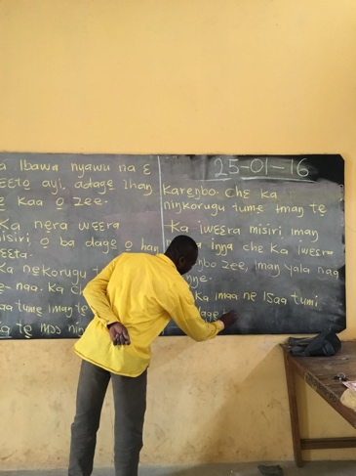
Figure 5. Teacher Samua writing the words of Safaliba children learning to read and write

With his mobile phone, he would photograph the chalkboard when it was full of the words the children had shared from their weekly fieldtrip. After class, these photos were emailed to activists and allies, who keyboarded the Safaliba from the photograph, adding digital photos from the visit with the community person and adding English to create photocopied and stapled little Safaliba-English bilingual books, usually only 8 pages long. Figure 6 is a photo of the cover of a little book produced from the voices of children who visited a Safaliba Imam with Teacher Samua.

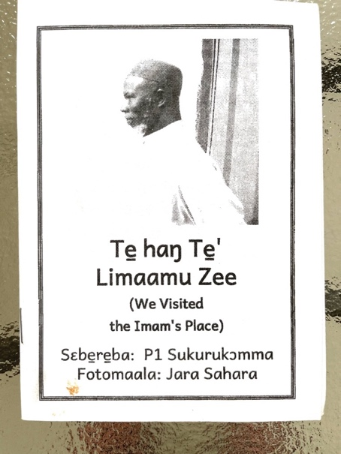
Figure 6. Safaliba-English bilingual cover of an 8-page little book from children’s language and produced by Teacher Samua the Safaliba activists and allies

One book was created for each child. Approximately one week later, each child in Teacher Samua’s class and all the other classes up through Primary Six in Samua’s school and a second school received their own copy of the little book. Additional schools occasionally also received little books. With all of the students having their own little book in hand, Teacher Samua led the class in choral read aloud sessions as he ran his finger under the words and had the children do the same. Children enthusiastically chimed in, and these events were great fun. Each day for a week, Teacher Samua also asked the children to draw and illustrate different themes from the little book of the week, as well as produce their own writings in invented spelling about each theme they drew. Teacher Samua, and sometimes a paraeducator, would move around the Primary One classroom and ask children to share aloud what they had written. Then the teacher or the paraeducator would write on the paper what that should look like in the Safaliba alphabet, modeling for each child how to hold a pencil, where to start a letter and finish it, and how to spell each word. Figure 7 shows Teacher Samua modeling writing what a student said they wrote in invented spelling. It also shows another photo of children drawing and writing about a theme from one of the little books that has their words in it and photos of one of their fieldtrips on foot during the Safaliba literacy program at their school.

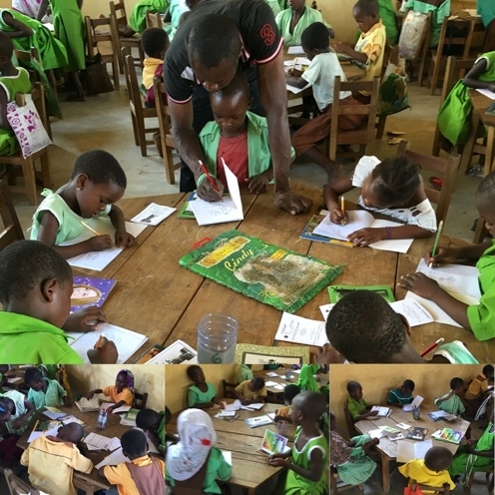
Figure 7. Teacher Samua modeling writing what a student had written in invented spelling. Other students drawing and writing Safaliba in Teacher Samua’s Primary One classroom

These more structured and rule-governed aspects of language and the material practices of writing with a pencil or pen were also taught to the whole group at different times in each lesson, particularly when introducing letter-sound correspondences. But even in these more structured and rule-governed activities around writing skills (e.g., holding a pencil, starting and ending a letter), Teacher Samua was keen on bringing forward student input and student voices.
This transformed the classroom into a less predictable, open, and creative space, where children were asked to suggest words that began with different letter sounds. Since children were also learning English from Teacher Samua, they sometimes suggested English words that began with the same sound and letter as a Safaliba word. Teacher Samua enthusiastically wrote the English words on the chalkboard alongside the Safaliba words, which was a form of translanguaging, as it promoted the free use of language from the full repertoire of student language shared aloud and was relevant to sound-letter correspondences and practices. In many ways, this approach incorporated an organic, child-centered, developmental, and holistic understanding of learning that fit well with Safaliba cultural practices that were fluid and porous and close to the materiality of the earth, seasonal change, the production of food from the land, its storage during dry season, and human interactions among the Safaliba.
Teacher Samua also provided opportunities for each child to discuss their drawings with each other. The evident engagement in these discussions was palpable and natural. Its palpability was embodied in the faces of these children, in their excited smiles and their fluid Safaliba talk. In a sense, school was decolonized at these moments and took on a new life. School was shedding its postcolonial positionings as Teacher Samua transformed it into a Safaliba school. The postcolonial Ghanaian leadership had mandated Gonja, which was little known by the children on the Safaliba tribal lands, and it was Teacher Samua, a Safaliba, who set meaningful meaning making in motion.
In such acts, the institution of schooling sheds its postcolonial trappings that otherwise distanced Safaliba children from themselves and from bridges to an international language, such as English. Teacher Samua, with the support of other teacher activists, allies, and his community leadership, as well as parents, was able to do this with his characteristic care, respect, and trust for his language, for Safaliba children, for his community, and for its culture (Sherris, 2017, 2019, 2020a, b).
Safaliba literacy lessons also included traditional storytelling and singing (Figure 8). Teacher Samua would tell a story and conclude with a song. Sometimes a volunteer paraeducator or a guest visiting the school would tell a traditional story. The children often knew when to participate in the story, which was not true when they were taught in Gonja and English. These were also transformative, as they drew on new ways to integrate schooling into Safaliba culture.
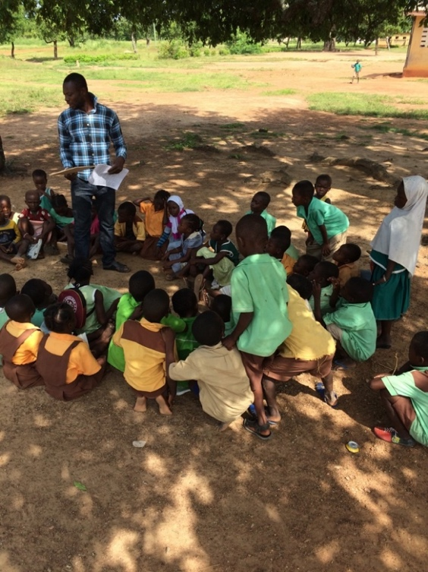
Figure 8. Teacher activist Samua preparing to tell a story to his Primary One class

Teacher Samua also facilitated structured and rule-governed practices in his classroom. These included spelling dictations, sound-letter matching games, and guessing games, all often with affordances for students to self- and peer-correct their writing with answer keys on the chalkboard. There were also rule-governed structured phonemic awareness group activities and alphabet tracing in the air to practice where to start an alphabet letter and where to end it. Students practiced writing letters of the alphabet (Figure 9) and small words in their notebooks during Safaliba lessons. Once a week, usually on Friday, Primary Six students joined Teacher Samua’s Primary One classroom and led small groups of children in small-group read aloud activities in Safaliba with the little book of the week. They themselves used the little books to improve their English.
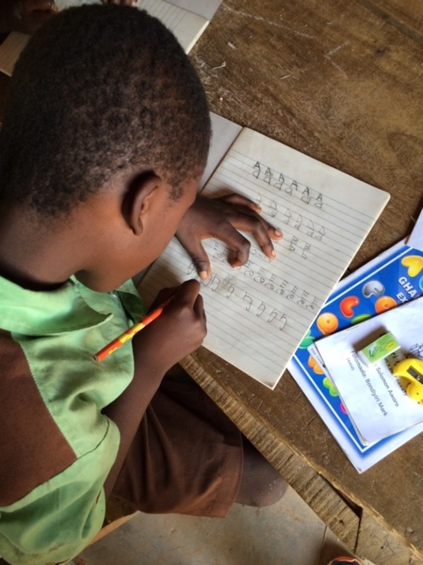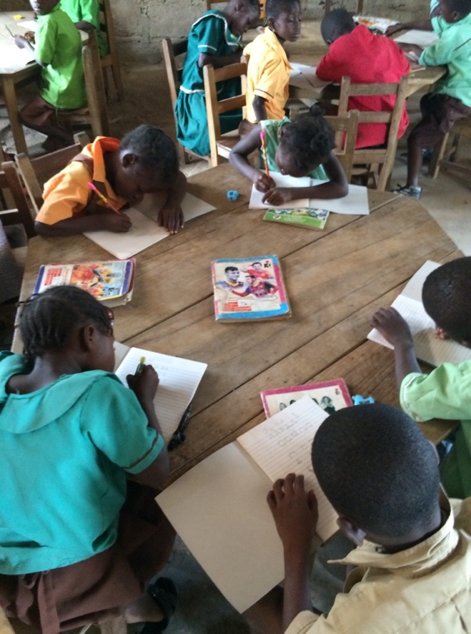
Figure 9. Primary One students practicing writing letters of the Safaliba alphabet
Te zaŋsera naŋ asɛbe biye! Chɛ sɛberaa!
We learn the alphabet! We write!

Clearly, the heavy lifting within and across the Safaliba language and literacy project increases the number of languages an individual can read. Prior to the work of Safaliba community activists, there was neither an orthography of the language nor dedicated teachers to bring it to children and adults. Now, with both an orthography and little books created of and for the Safaliba with digital photos, a few laptops, and a photocopy machine, there is an increase in the number of languages an individual can read and write and an increase in the number of individuals who can read and write. Teacher activists teach Safaliba reading and writing adults and children. The production and reproduction of Safaliba reading and writing attracts the attention of the academy. Such attention potentially reduces or mediates marginalizing social forces in society, such as the wholesale adoption of Gonja as the only language of early schooling on Safaliba tribal lands. This raises the linguistic capital among all Safaliba and the academy as it increasingly decolonizes the institution of schooling -- ‘Safalibanizing’ it, if you will. Moreover, the processes of producing and reproducing Safaliba through writing and reading it, affirm, respect, and welcome potential family, clan, and community involvement in institutions and schooling (e.g., through Safaliba storytelling; talk about the community, country, livelihood, and vocations from the little books).
This project presents an evidentiary trail of grassroots language and literacy development that, while small scale, exemplifies an ecolinguistically sustainable path for additional Ghanaian languages in multilingual contexts, as they too will one day disrupt the discourse of repression by postcolonial erasure.
Conclusion
The two projects are very different. The large project in The Gambia has in place state mechanisms that are leveraged, whereas the small project in Ghana leveraged its community aspirations. The Gambia project is top-down; the Safaliba project is bottom-up. However, in both projects we demonstrate that the four goals are at play, although linguistic capital will take time to bear fruit. As far as next steps, in the Safaliba Project, scaling it up would be possibly of interest across additional unrecognized languages in the surrounding areas and beyond. In The Gambia project, deepening the roots within communities might be a next step. Scaling up and deepening roots would mediate imbalances in power leveraged in top-down and bottom-up processes. In both projects, developing workshops for writers and promoting and supporting family literacy might be encouraged.
References
Ancarno, C. Bouy, B., & Jeng, M. (forthcoming). Challenges for Gambian primary schools aiming to enhance literacy through the use of national languages. In E. Erling, J. Clegg, C. Rubagumya, & C. Reilly (Eds.), Multilingual learning in Sub-Saharan Africa: Assessment, ideologies and policies. (Vol. 2). Routledge.
Bourdieu, P. (1977). The economics of linguistic exchanges. Social Science Information, 16(6), 645-668.
Bourdieu, P. (1983). Language and symbolic power. Cambridge: Harvard University Press.
Davidson, M. (2013). Books that children can read: Decodable books and book leveling. Washington, DC: U. S. Agency for International Development (USAID).

Dubeck, M. M., & Gove, A. (2015). The early grade reading assessment (EGRA): Its theoretical foundation, purpose, and limitations. International Journal of Educational Development, 40, 315-322. The early grade reading assessment (EGRA): Its theoretical foundation, purpose, and limitations - ScienceDirect
Ghana. Ghana's Constitution of 1992 with Amendments through 1996. http://extwprlegs1.fao.org/docs/pdf/gha129754.pdf
Gove, A., & Wetterberg, A. (2011). The Early Grade Reading Assessment: Applications and interventions to improve basic literacy. Research Triangle Institute. RTI Press. The Early Grade Reading Assessment: Applications and Interventions to Improve Basic Literacy (ed.gov)
Hymes, D. (1980). What is ethnography. In D. Hymes (Ed.), Language in education: Ethnolinguistic essays (pp. 88–103). Washington, DC: Center for Applied Linguistics.
Lewis, M.P., Simons, G.F., & Fennig, C.D. (Eds.) (2016). Ethnologue: Languages of Ghana. Nineteenth edition. Dallas, TX: SIL International.
Population Pyramid. (2021). Population pyramids of the world from 1950 to 2100. Population of Gambia 2021 - PopulationPyramid.net
Report on Early Grade Reading ability assessment. (2011). Republic of The Gambia: Ministry of Basic and Secondary Education. In-Service Education and Training Unit.
Rosekrans, K., Sherris, A., & Chatry-Komarek, M. (2012). Education reform for the expansion of mother-tongue education in Ghana. International Review of Education, 58(5), 593-618.
Schaefer, P. (2008a). Safaliba syntax in principles and parameters theory. (Academic Seminar Week: Proceedings of the 2005 and 2006 Seminars). GILLBT Working Papers, 2, 27–41.
Schaefer, P. (2008b). ‘Focus’ markers: Theory and application to Safaliba. (Academic Seminar Week: Proceedings of the 2005 and 2006 Seminars). GILLBT Working Papers,2, 45–55.
Schaefer, P. (2008c). Safaliba pronoun forms and participant reference. (Academic Seminar Week: Proceedings of the 2005 and 2006 Seminars). GILLBT Working Papers, 2, 76–79.
Schaefer, P. (2009). Narrative storyline marking in Safaliba: Determining the meaning and discourse function of a typologically-suspect pronoun set. Dissertation, University of Texas at Arlington. https://rc.library.uta.edu/uta-ir/handle/10106/1669
Schaefer, P. (2015). Hot eyes, white stomachs: Emotions and character qualities in Safaliba metaphor. In E. Piirainen and R. Sherris (Eds.), Language endangerment: Disappearing metaphors and shifting conceptualization (pp. 91–110). Amsterdam: John Benjamins. https://doi.org/10.1075/clscc.7.04sch
Schaefer, P., & Schaefer, J. (2003). Collected field reports on the phonology of Safaliba. (Collected Language Notes, 25) Legon, Ghana: Institute of African Studies, University of Ghana.
Schaefer, P., & Schaefer, J. (2004). Verbal and nominal structures in Safaliba. Studies in the languages of the Volta Basin II. In M. E. Kropp Dakubu & E. K. Osam (Eds.), Languages of the Volta Basin II (pp. 183–201). Legon, Ghana: Department of Linguistics, University of Ghana.
Sherris, A. (2017). Talk to Text Safaliba literacy activism: Grassroots Ghanaian educational language policy. Writing & Pedagogy, 9(1), 163-195.
Sherris, A. (2019). Early childhood Safaliba literacy in Ghana. In A. Sherris & J. K. Peyton (Eds.), Teaching writing to children in Indigenous languages: Instructional practices from global contexts (pp. 70–88). Routledge.
Sherris, A. (2020a). Safaliba community language awareness: “Safale̱ba—A dage̱ya ka o̱ bebee!” [“Safaliba—it is important for it to exist!”], Language Awareness, 29(3-4), pp. 304-319.
Sherris, A. (2020b). Situated Safaliba practices in school literacies that resist dominant discourses in Ghana. In A. Sherris & S. Penfield (Eds.), Rejecting the marginalized status of minority languages: Educational projects pushing back against language endangerment (pp. 135-151). Bristol, UK: Multilingual Matters.
Sherris, A., & Peyton, J. K. (2019). Teaching writing to children in Indigenous languages: Instructional practices from global contexts. New York and London. Routledge.
Sherris, A., Schaefer, P., Aworo, M. S. (2019). The paradox of translanguaging in Safaliba: A rural indigenous Ghanaian language. In A. Sherris & E. Adami (Eds.), Making signs, translanguaging ethnographies: Exploring urban, rural and educational spaces (pp. 152-169). Bristol, UK: Multilingual Matters.
Sherris, A., & Yakubu, K. (anticipated publication 2022). Drumming, storytelling, and writing: Indigenous Safaliba sign making in rural Ghana. In R. Horowitz (Ed.), The Routledge handbook of international research on writing. New York: Routledge.
Simons, G. F., & Fennig, C. D. (Eds.). (2018). Ethnologue: Languages of the world, Twenty-first edition. Dallas, Texas: SIL International. http://www.ethnologue.com
Trudell, B. (2016). The impact of language policy and practice on children’s learning: Evidence from Eastern and Southern Africa. Commissioned by UNICEF Eastern and Southern Africa Regional Office (ESARO), Basic Education and Gender Equality (BEGE) Section.
UNESCO Institute for Statistics. (2021). Literacy. https://en.unesco.org/themes/literacy
USAID and EQUALL. (2012). Education quality for all: Final report. USAID/Ghana Cooperative Agreement Number 641-A-00-04-00237.
USAID and Ghana Partnership for Learning. (2015). Learning annual performance report, 4th quarter (FHI 360). DOC: PA00MWDM.
USAID and Ghana Partnership for Learning. (2017). Year three quarterly performance report, (FHI 360). https://pdf.usaid.gov/pdf_docs/PA00T3GS.pdf
World Bank. (2021). Loud and Clear: Effective Language of Instruction Policies for Learning. Loud and Clear: Effective Language of Instruction Policies for Learning (worldbank.org)

